**Agile Methodology**

Agile methodology is a people-focused, result-focused approach to software development that respects our rapidly changing requirements. It is focused on adaptive planning, self-organization, and quicker delivery times. It’s flexible, fast and aims for continuous improvement in quality using tools like Scrum, Extreme Programming, Kanban etc..

Features:

* It abandons the risk of spending or years on a process that ultimately fails because of small mistakes in early phases
* It relies on taking on board the entire team rather than a one person while giving the estimations
* It adapts the process where entire team will work directly with customers to understand the goals and provide solutions in a fast and incremental way

1. Faster, Smaller
2. Communication
3. Feedback
4. Trust
5. Adjust

Most popular Agile Methodology used overall in the market is Scrum

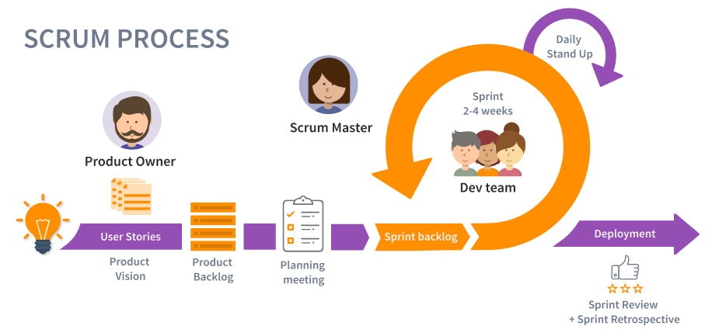

* Product owner makes a priority list of features to be developed knows as product backlog
* Scrum Team takes one small piece of the top of the product backlog and create a sprint backlog to implement it
* The team completes the sprint backlog typically in 2-4 weeks (called as sprint cycle) where the progress is assessed on daily basis in a meeting called as (Daily Scrum or Standup meeting)
* The Scrum master keeps the team focused on the goal
* At the sprint’s end the work is ready to ship or show. The team closes the sprint with a review and then starts the new sprint

**Framework of Scrum:**

Roles:

* Product Owner
  + Defines the features of the product
  + Makes scope vs schedule decisions
  + Responsible for achieving financial goals of the project
  + Prioritize the product backlog
  + Adjust the features and priority every sprint as needed
  + Accepts or rejects work results
* Scrum Master
  + Responsible for enacting scrum values and practices
  + Removes impediments
  + Coaches the team to their best possible performance
  + Enable close cooperation across all roles and functions
  + Shield the team from external interference
* Scrum Team
  + Typically 5-9 people
  + Cross functional
  + Members should be full-time
  + Teams are self-organizing
  + Memberships should change only in between sprints

Ceremonies:

* Sprint Planning
  + Who – Team, Scrum master and product owner
  + Agenda – Discuss top priority products, Team selects which to do (Sprint Goal and Sprint Backlog)
  + Why – Know what will be worked on, understand it enough to do it.
* Sprint Review
  + Team presents what it accomplished during the sprint
  + Typically takes the form of a demo of new features or underlying architecture
  + It is informal : 2 hours prep time rule, no slides
  + Whole team participates
  + Invite the world
* Sprint Retrospective
  + Periodically take a look at what is and is not working
  + Typically around 30 mins
  + Done after every sprint
  + Whole team participates
  + Whole team gathers and discuss what they’d like to :
    - Start doing
    - Stop doing
    - Continue doing
* Daily Scrum Meeting
  + Happens Daily
  + Not more than 15 mins
  + Stand-up
  + It is not a problem solving
  + Whole world is invited
  + Only team members, scrum master and product owner can talk
  + Helps avoid other unnecessary meetings
  + Everyone has to answers 3 questions
    - What did you do yesterday?
    - What will you do today?
    - Is anything in your way?

Artifacts:

* Product Backlog
  + The requirements also called as user stories
  + A list of all desired work on the project
  + Ideally expressed such that each item has value to the users or customers of the product
  + Prioritized by the product owner
  + Reprioritized at the start of each sprint
* Sprint Backlog
  + Individuals signup for work of their own choosing
  + Estimated work remaining is updated daily
  + Any team member can add, delete or change the sprint backlog
  + Work for the sprint emerges
  + If work is unclear , define a sprint backlog item with a large amount of time and break it down later
  + Update work remaining as more becomes known
* Burndown Charts

